**University Institute of Engineering, Chandigarh University**

**Department of Computer Science & Engineering**

**Date: 19-03-2021**

|  |  |  |  |  |  |  |  |
| --- | --- | --- | --- | --- | --- | --- | --- |
| S. No | Project Proposal (5 Marks) | Synopsis (8 Marks) | **Project Design and Modeling (10)** | **Project Implementation (12)** | **IEEE Paper/ Patent/ H/w Product (5)** | **Final Project Assessment +Viva (20)** | Mentor Signature |
| 19BCS1184 | 4 | 8.5 | 8.5 |  |  |  |  |
| 19BCS1182 | 4 | 8.5 | 8.5 |  |  |  |  |

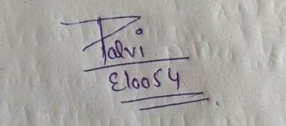

**Project Teacher Signature**

**Dr. Meenu Gupta, Dr. Sumedha Arora**

**Assistant Professor and Project Coordinator**

**Email: Project.cse@cumail.in**